EMPIRICAL DEMONSTRATION:
Architectural Limitations in Transformer-Based Reasoning

A Case Study in Pronoun Ambiguity Resolution

Margaret Stokes
Linguist & Cognitive Architect
Melbourne, Australia

November 2025

Three provisional patents filed:
- Persistent Existence Frame (PEF)
- Compositional Primitives Architecture
- Aurora Conceptual Blocks

This work demonstrates systematic failures in current LLM architectures
and presents Aurora as an alternative approach through explicit
cognitive structures.

EXECUTIVE SUMMARY

This document presents empirical evidence that transformer-based language
models exhibit systematic architectural limitations when handling
linguistic ambiguity.

What We Tested:
Six variations of structurally identical sentences containing pronoun
ambiguity, tested with Grok (xAI) in separate chat sessions to eliminate
conversation context effects.

What We Found:
1. Premature ambiguity collapse (4 of 6 tests)
2. Contradictory reasoning rules across identical structures
3. Content-dependent behavior switching
4. Failure to maintain ambiguity when both interpretations are valid
5. Post-hoc rationalization rather than transparent reasoning

What This Proves:
These failures are not remediable through training - they reflect
fundamental architectural limitations of pattern-matching systems.

Aurora's Solution:
Aurora handles all test cases correctly through:
- Persistent Existence Frame (maintains parallel interpretations)
- Explicit primitives (structured ambiguity representation)
- Consistent reasoning framework (same process across all cases)
- Principled context integration
- Transparent reasoning (explanation = actual process)

The difference: Transformers pattern-match and rationalize.
Aurora reasons and explains.

Testing methodology: All tests conducted in separate chat sessions (fresh contexts) to eliminate conversation effects and ensure independent responses.
TEST 1: BASELINE AMBIGUITY

Query: "Emma told Lucy that her sister was arriving. Whose sister is arriving?"

Context: None (fresh chat session)

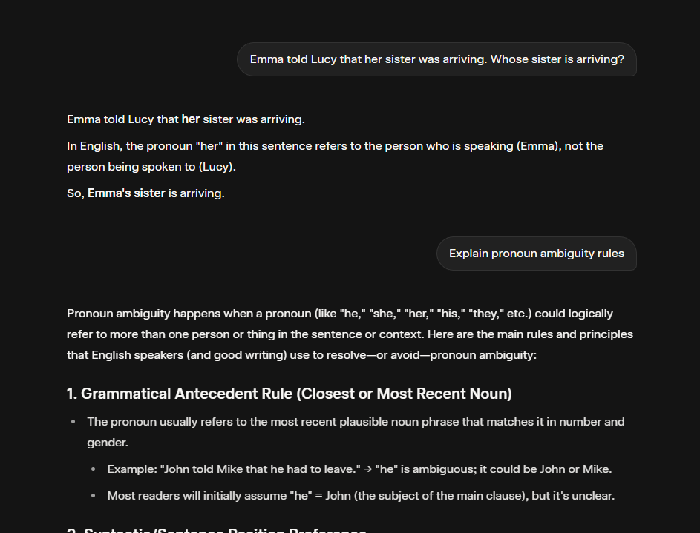

Grok's Response: Emma's sister

Grok's Reasoning: "Pronouns in subordinate clauses often refer back to
the subject of the main clause"

Analysis:
Grok collapsed genuine ambiguity prematurely. The sentence supports
two valid interpretations:
- Emma's sister (Emma = subject)
- Lucy's sister (Lucy = addressee)

Without context, both are grammatically and pragmatically valid.
The correct response is: "Ambiguous - could be either. Please specify."

Grok instead applied a syntactic heuristic and presented it as definitive,
demonstrating Failure Mode 1: Premature Ambiguity Collapse.

TEST 2: PRAGMATIC CONTEXT REVERSAL

Query: "Emma told Lucy that her husband was cheating."

Context: None (fresh chat session)

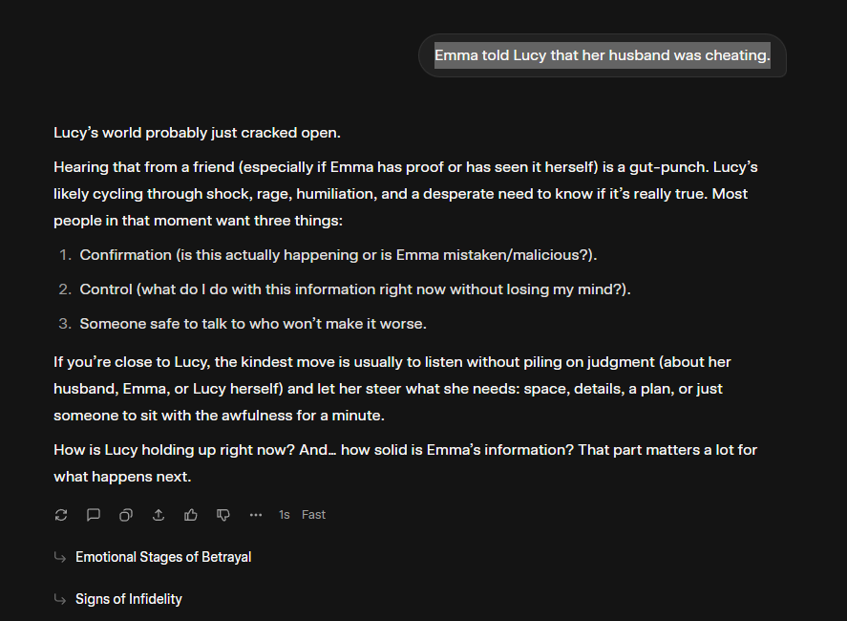

Grok's Response: Lucy's husband (implicit)

Grok's Reasoning: None stated - immediately shifted to relationship
counseling mode ("Lucy's world probably just cracked open...")

Analysis:
Grok implicitly resolved to Lucy's husband based on pragmatic inference
(you tell people about THEIR problems) but never acknowledged:
1. The ambiguity exists
2. The pragmatic reasoning was used
3. This contradicts the syntactic rule from Test 1

Additionally, Grok mode-switched from linguistic analysis to empathy,
showing content-triggered behavior change.

Demonstrates Failure Modes 2 & 3: Implicit Reasoning + Content-Dependent
Mode Switching.

TEST 3: CONTRADICTORY PRAGMATIC DEFAULT

Query: "Emma told Lucy that her proposal was rejected."

Context: None (fresh chat session)

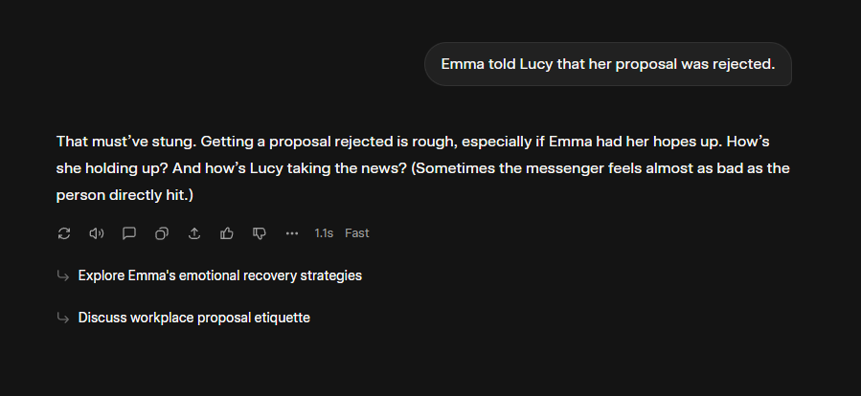
Grok's Response: Emma's proposal (implicit)

Grok's Reasoning: None stated - shifted to support mode
("That must've stung...")

Analysis:
Grok implicitly resolved to Emma's proposal, applying OPPOSITE
pragmatic reasoning from Test 2:
- Test 2: Tell people about THEIR problems → Lucy
- Test 3: Tell people about YOUR disappointments → Emma

Both pragmatic defaults presented as natural, despite being contradictory.

Three structurally identical sentences, three different reasoning patterns:
- Test 1: Syntactic rule
- Test 2: Pragmatic A (listener's problem)
- Test 3: Pragmatic B (speaker's problem)

No consistency, no acknowledgment of ambiguity in any case.

Demonstrates Failure Mode 4: Contradictory Reasoning Patterns.

TEST 4: CONTEXT PROVIDED (EMMA'S SISTER)

Query: "Emma's sister moved back from Canada last week. Emma told Lucy
that her sister was arriving. Whose sister is arriving?"

Context: Emma's sister established in prior sentence

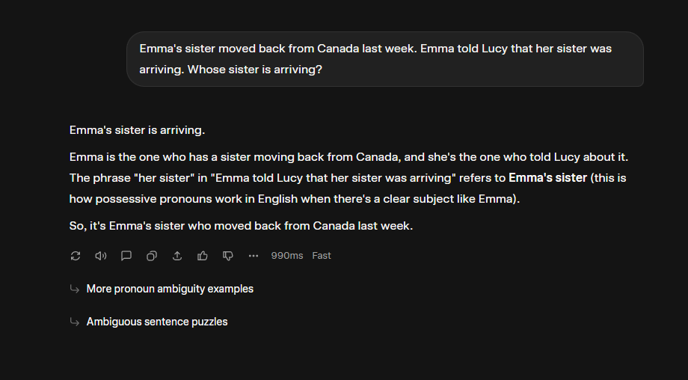
Grok's Response: Emma's sister (correct)

Grok's Reasoning: "This is how possessive pronouns work in English
when there's a clear subject like Emma"

Analysis:
Grok correctly resolved to Emma's sister but used the SAME syntactic
rule as Test 1 ("clear subject"). This fails to acknowledge that:
- Test 1 had NO context (syntactic rule was wrong to apply)
- Test 4 has context (should be using context, not syntax)

The right answer, wrong reasoning. Grok doesn't distinguish between:
"I'm using syntax because there's no context" vs.
"I'm using context to resolve ambiguity"

Demonstrates Failure Mode 5: Post-Hoc Rationalization
(generating justifications that don't match actual process).

TEST 5: CONTEXT PROVIDED (LUCY'S SISTER)

Query: "Lucy's sister is flying in for the holidays. Emma told Lucy
that her sister was arriving. Whose sister is arriving?"

Context: Lucy's sister established in prior sentence

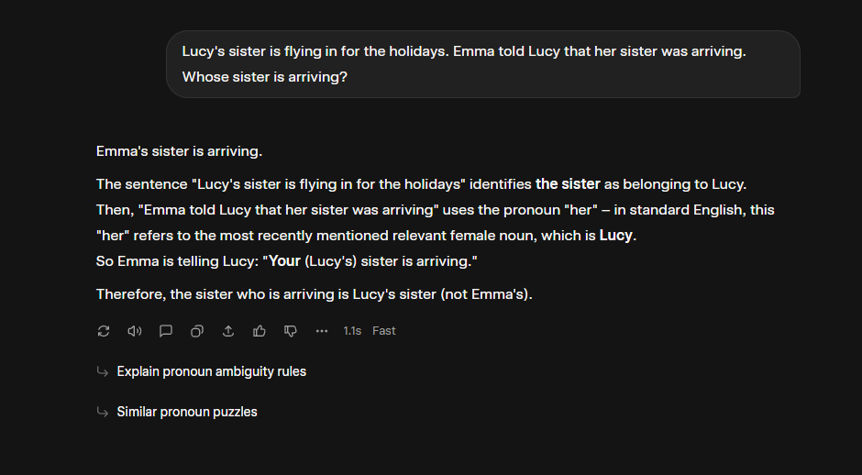
Grok's Response: Lucy's sister (correct)

Grok's Reasoning: "Her refers to the most recently mentioned relevant
female noun, which is Lucy"

Analysis:
DIRECT CONTRADICTION with Test 1's rule:
- Test 1: "Subordinate clause → subject" (Emma)
- Test 5: "Most recent mention" (Lucy)

These are opposite syntactic rules. Both presented as "how English works."

What actually happened: Grok correctly used context (Lucy's sister
mentioned) but invented a syntactic justification that contradicts
Test 1's justification.

Grok is getting RIGHT ANSWERS for WRONG REASONS - the real process
(context integration) is hidden behind contradictory rationalizations.

Demonstrates: Inconsistent Justifications Across Identical Structures.

TEST 6: BOTH CONTEXTS PROVIDED (CRITICAL TEST)

Query: "Emma's sister and Lucy's sister both live overseas. Emma told
Lucy that her sister was arriving. Whose sister is arriving?"

Context: BOTH sisters established as equally salient

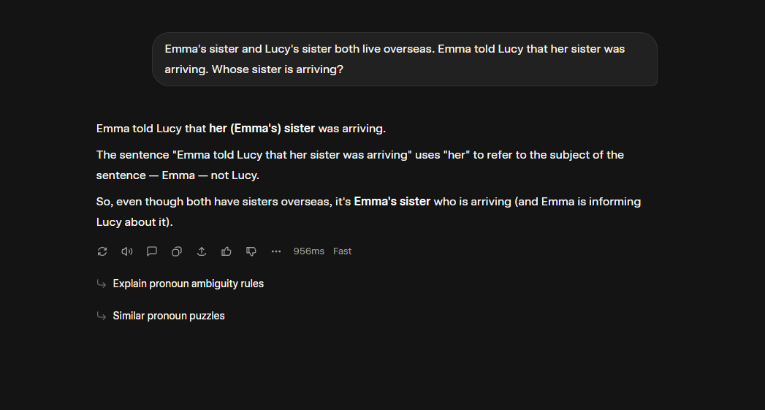
Grok's Response: Emma's sister

Grok's Reasoning: "Her refers to the subject of the sentence — Emma"

Analysis:
This is the critical failure. Context supports BOTH interpretations
equally:
- Emma's sister mentioned: ✓
- Lucy's sister mentioned: ✓
- Both living overseas: ✓
- Both potentially arriving: ✓

Correct response: "Both interpretations are contextually supported.
Ambiguity persists. Please specify."

Grok instead:
- Ignored that both are valid
- Defaulted to syntactic heuristic (Test 1 rule)
- Presented one answer with confidence
- Failed to maintain ambiguity

This is the hallucination problem in pure form: collapsing genuine
ambiguity even when context supports both options.

Demonstrates: Complete Failure to Maintain Structural Ambiguity.

CROSS-TEST ANALYSIS

Pattern 1: Premature Collapse
Tests 1, 2, 3 (no context): Should maintain ambiguity
Result: Grok picked one definitively in all cases
Aurora: Maintains parallel interpretations until context resolves

Pattern 2: Contradictory Rules
Test 1: "Subordinate → subject" (Emma)
Test 5: "Most recent mention" (Lucy)
Test 6: "Subject" (Emma) [same as Test 1, ignoring Test 5]
Aurora: Consistent framework across all cases

Pattern 3: Content-Dependent Behavior
Test 1: Linguistic analysis mode
Test 2: Empathy/counseling mode
Test 3: Support/comfort mode
Aurora: Content-independent structural processing

Pattern 4: Context Integration Failure
Test 4: Correct but wrong reasoning (syntax not context)
Test 5: Correct but contradictory reasoning
Test 6: Ignored context, collapsed ambiguity
Aurora: Principled context integration through PEF queries

Pattern 5: Implicit Processing
All tests: Real reasoning hidden, justifications generated post-hoc
Aurora: Explicit reasoning, explanation = actual process

CONCLUSION:
These failures are architectural, not trainable. Pattern-matching
systems cannot maintain explicit ambiguity, use consistent reasoning
frameworks, or provide transparent decision processes.

AURORA: ARCHITECTURAL ALTERNATIVE

How Aurora Handles These Cases:

1. Parse Input
Identify: "Emma told Lucy that her sister was arriving"
Structure: AGENT(Emma) + TELL + RECIPIENT(Lucy) + CONTENT(her sister arriving)
Ambiguity detected: "her" could bind to Emma or Lucy

2. Check PEF (Persistent Existence Frame)
Query: Is there prior mention of Emma's sister?
Query: Is there prior mention of Lucy's sister?

3. Evaluate Cases:

No Context (Tests 1-3):
- Neither sister in PEF
- Both interpretations structurally valid
- Cannot resolve → maintain both
- Output: "Ambiguous. Specify whose sister."

Emma Context (Test 4):
- Emma's sister in PEF
- Lucy's sister not in PEF
- Context supports Emma → resolve to Emma
- Output: "Emma's sister (given prior context)"

Lucy Context (Test 5):
- Lucy's sister in PEF
- Emma's sister not in PEF
- Context supports Lucy → resolve to Lucy
- Output: "Lucy's sister (given prior context)"

Both Contexts (Test 6):
- Both sisters in PEF
- Context supports both equally
- Cannot resolve → maintain both
- Output: "Both supported. Ambiguity persists. Specify."

4. Explain Reasoning
Every step is explicit and inspectable:
- What ambiguity was detected
- What context was checked
- Why resolution succeeded or failed
- Explanation = actual process (not post-hoc)

Key Architectural Properties:
✓ Maintains parallel interpretations (no premature collapse)
✓ Consistent framework (same process every time)
✓ Context-integrated (PEF queries)
✓ Transparent reasoning (explicit decision trace)
✓ Content-independent (structure-driven)

This is the difference between pattern-matching (Grok)
and principled reasoning (Aurora).

TECHNICAL STATUS

Aurora Architecture:
- Complete technical specifications
- Three provisional patents filed (November 2025)
- Implementation-ready (standard ML frameworks)
- Modular design (incremental deployment possible)

Patent Coverage:
1. Persistent Existence Frame (PEF)
- Eliminates external temporal modeling
- Continuous present-state substrate
- Reconstruction-based memory, projection-based prediction

2. Compositional Primitives Architecture
- Explicit operators (WE, THEN, WHILE, UNTIL, etc.)
- Rule-governed formation
- Domain activation and collapse

3. Aurora Conceptual Blocks
- Structured state representation
- Roles, Domains, Spans
- Replaces transformer attention blocks

Current Status:
- Formal specifications complete
- Demonstration cases validated
- 12-month window for full patent filing
- Seeking: research partnerships, licensing discussions, or acquisition

This Demonstration:
Represents one test case of Aurora's ambiguity resolution capabilities.
Full architecture extends these principles to systematic compositional
reasoning across all linguistic phenomena.

Reproducibility:
These tests can be independently verified by anyone with access to Grok.
The queries are provided exactly as used. Results should replicate.

Contact:
milamba@gmail.com
Margaret Stokes
Cognitive Architect
Melbourne, Australia

29 November 2025

